Data Technician
Week 2 Workbook
Tableau and Power BI

Name: Slondiwe Mkhize
Course Date: 13/July/2026
Table of contents
Day 2: Task 1 3
Day 2: Task 2 6
Day 3: Task 1 8
Day 3: Task 2 (Optional) 9
Day 4: Task 1 10
Day 4: Task 2 12
Day 4: Task 3 (Optional) 13
Course Notes 13
Additional Resources to learn and Practice 14

Day 2: Task 1
Start new Tableau page.
Download GapminderHealth.xlsx dataset.
Using the Health GapminderHealth dataset, conduct an analysis to find trends and key information that could be used by an organisation for future support.

Column Name | Description | Data Type | Example
Continent | Continent where the country is located. | Text | Asia
Country | Name of the country. | Geographic | Afghanistan
Year | Year of observation or measurement. | Numeric | 1990
Life Expectancy | Average number of years a person is expected to live at birth. | Numeric | 48.9
Gender | Gender group for which the metrics are reported. | Text | Women
BMI | Average Body Mass Index of the population. | Numeric | 20.7
Blood Pressure | Average blood pressure measurement of the population. | Numeric | 124
Cholesterol | Average cholesterol level of the population. | Numeric | 4.55
Lung Cancer | Lung cancer incidence | Numeric | 194
Liver Cancer | Liver cancer incidence | Numeric | 107
Stomach Cancer | Stomach cancer incidence | Numeric | 406
Population | Total population of the country for the specified year. | Numeric | 6,067,694
Population Growth | Annual population growth rate expressed as a percentage. | Decimal (%) | 6.75

Scenario:
You are a data analyst working for a global health organization. Your team needs to quickly understand key health trends and disparities across different countries and continents. They are particularly interested in seeing how health metrics vary and how life expectancy has changed over time.
Your Task:
Using the GapminderHealth dataset in Tableau, create a series of visualizations to answer the following questions. Focus on using basic chart types and features.

Instructions & Deliverables:
- Life Expectancy by Continent (Most Recent Year):
  - Create a bar chart showing the average Life Expectancy for each Continent.
  - Filter the data to show only the most recent year available in the dataset.
  - Sort the continents by Life Expectancy in ascending or descending order.
  - Deliverable: A worksheet named "Life Expectancy by Continent".

- Life Expectancy Trend Over Time (Top 5 Countries):
  - Create a line chart to show the trend of Average Life Expectancy over Year.
  - Filter the data to display only the top 5 countries with the highest average Life Expectancy across all years. (Hint: Use a Top N filter on Country based on Average Life Expectancy).
  - Use Country on Colour to differentiate the lines.
  - Deliverable: A worksheet named "Life Expectancy Trend".

- Population Distribution by Gender (Latest Year for a Selected Country):
  - Create a pie chart showing the Population distribution by Gender.
  - Add a Country filter to the worksheet (e.g., set it to 'United States' or a country of your choice initially, but ensure the filter is available for interaction). Change filter type to Single Value (dropdown).
  - Filter the data to show only the most recent year available in the dataset.
  - Add Population to Labels. Right click on sum (Population) under marks card and change Quick table calculation to Percentage of Total.
  - Deliverable: A worksheet named "Population by Gender".

- Health Metric Comparison (Scatter Plot):
  - Create a scatter plot to explore the relationship between Average Life Expectancy and Average BMI.
  - Place Life Expectancy on one axis and BMI on the other.
  - Use Country on Detail to represent individual countries as points.
  - Use Continent on Colour to differentiate points by continent.
  - Add Continent to filters and show filter.
  - Deliverable: A worksheet named "Life Expectancy vs BMI".
- Viz of your Choice
  - Use any other fields or chart types to add another visual.

- Dashboard Creation:
  - Combine all worksheets (Life Expectancy by Continent, Life Expectancy Trend, Population by Gender, Life Expectancy vs BMI, Viz of your Choice) into a single dashboard.
  - Ensure the "Country" filter on the "Population by Gender" worksheet applies to the "Life Expectancy Trend" worksheet as well (if applicable or make it a global filter if you prefer the user to select one country to see all relevant details for it). Self-correction: Given it's basic, let's keep the filters simple. Just place the filter on the dashboard and ensure it's applied to the relevant sheet(s) where it makes sense.
  - Add a Title to your dashboard, e.g., "Global Health Insights".
  - Publish your dashboard to Tableau Public Website
  - Deliverable: A dashboard named "Global Health Dashboard".

Paste your dashboard screens here | 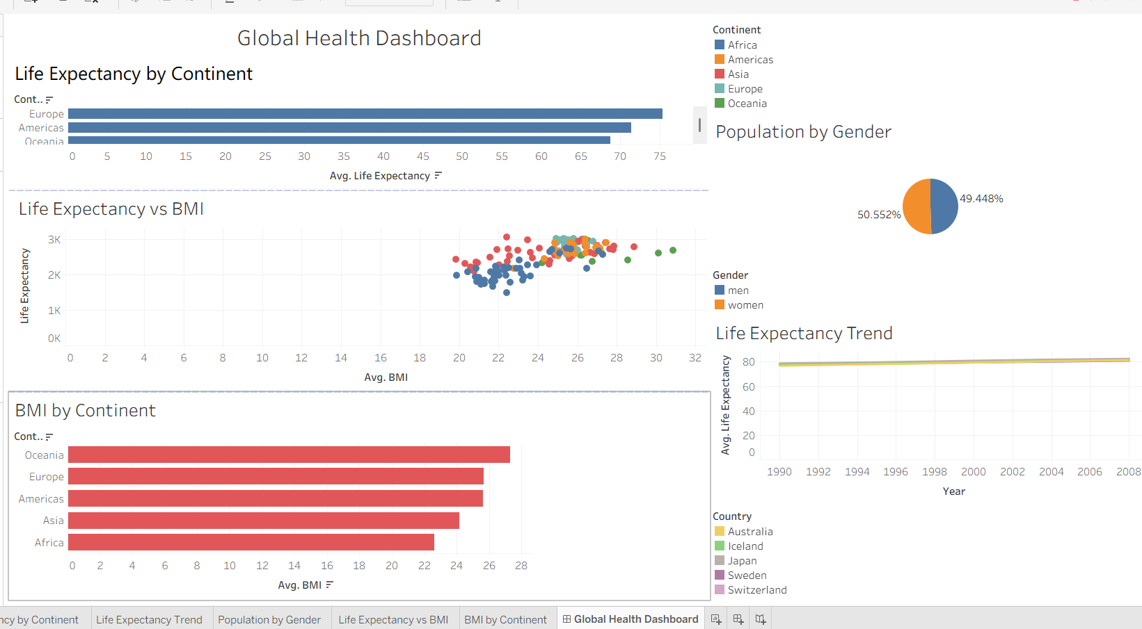
What did you find and any reflections on how the NHS could use this? | The first paragraph shows that Europe has the highest life expectancy, while Africa and parts of Asia show lower averages. This could be due to a number of factors, including better healthcare systems and improved access to medication. Population distribution also shows that larger populations may require more resources and can place additional pressure on the healthcare system. The pie chart demonstrates an almost 50/50 gender split, although the proportions differ between countries.  The scatter plot comparing life expectancy and BMI suggests that countries with higher life expectancy tend to have moderate to high average BMI levels. This indicates that BMI alone does not determine health outcomes.  The NHS can use this information to implement preventative measures by analysing countries with higher life expectancy and better health outcomes. It can also target areas with lower life expectancy and provide them with educational resources and additional funding. The NHS could use the dashboard to analyse trends and make evidence-based decisions. This information can support preventative strategies to address obesity, promote healthy lifestyles, and provide the public with greater knowledge on how to prevent chronic diseases, ultimately improving long-term health across different populations.
Link to your dashboard | Global health Dashboard | Tableau Public

Once you finish this task save and close Tableau.

Day 2: Task 2
Start Tableau Public Desktop and import the Spotify dataset
Extension_Task_SpotifyFeatures.csv, conduct an analysis to find trends and key information that could be used by an organisation for future projects.
Column Description
- genre: The genre in which the track belongs
- artist_name: The artists' names who performed the track.
If there is more than one artist, they are separated by a;
- track_name: Name of the track
- track_id: The Spotify ID for the track
- popularity: The popularity of a track is a value between 0 and 100, with 100 being the most popular. The popularity is calculated by algorithm and is based, in the most part, on the total number of plays the track has had and how recent those plays are. Songs that are being played a lot now will have a higher popularity than songs that were played a lot in the past. Duplicate tracks (e.g. the same track from a single and an album) are rated independently. Artist and album popularity is derived mathematically from track popularity.
- acousticness: A confidence measure from 0.0 to 1.0 of whether the track is acoustic. 1.0 represents high confidence the track is acoustic
- danceability: Danceability describes how suitable a track is for dancing based on a combination of musical elements including tempo, rhythm stability, beat strength, and overall regularity. A value of 0.0 is least danceable and 1.0 is most danceable
- duration_ms: The track length in milliseconds
- energy: Energy is a measure from 0.0 to 1.0 and represents a perceptual measure of intensity and activity. Typically, energetic tracks feel fast, loud, and noisy. For example, death metal has high energy, while a Bach prelude scores low on the scale
- instrumentalness: Predicts whether a track contains no vocals. "Ooh" and "aah" sounds are treated as instrumental in this context. Rap or spoken word tracks are clearly "vocal". The closer the instrumentalness value is to 1.0, the greater likelihood the track contains no vocal content
- key: The key the track is in. Integers map to pitches using standard Pitch Class notation. E.g. 0 = C, 1 = C♯/D♭, 2 = D, and so on. If no key was detected, the value is -1
- liveness: Detects the presence of an audience in the recording. Higher liveness values represent an increased probability that the track was performed live. A value above 0.8 provides strong likelihood that the track is live
- loudness: The overall loudness of a track in decibels (dB)
- mode: Mode indicates the modality (major or minor) of a track, the type of scale from which its melodic content is derived. Major is represented by 1 and minor is 0
- speechiness: Speechiness detects the presence of spoken words in a track. The more exclusively speech-like the recording (e.g. talk show, audio book, poetry), the closer to 1.0 the attribute value. Values above 0.66 describe tracks that are probably made entirely of spoken words. Values between 0.33 and 0.66 describe tracks that may contain both music and speech, either in sections or layered, including such cases as rap music. Values below 0.33 most likely represent music and other non-speech-like tracks
- tempo: The overall estimated tempo of a track in beats per minute (BPM). In musical terminology, tempo is the speed or pace of a given piece and derives directly from the average beat duration
- time_signature: An estimated time signature. The time signature (meter) is a notational convention to specify how many beats are in each bar (or measure). The time signature ranges from 3 to 7 indicating time signatures of 3/4, to 7/4.
- valence: A measure from 0.0 to 1.0 describing the musical positiveness conveyed by a track. Tracks with high valence sound more positive (e.g. happy, cheerful, euphoric), while tracks with low valence sound more negative (e.g. sad, depressed, angry)

There is no set scope for the analysis, simply to find trends and document them below:

Paste your print screens here | 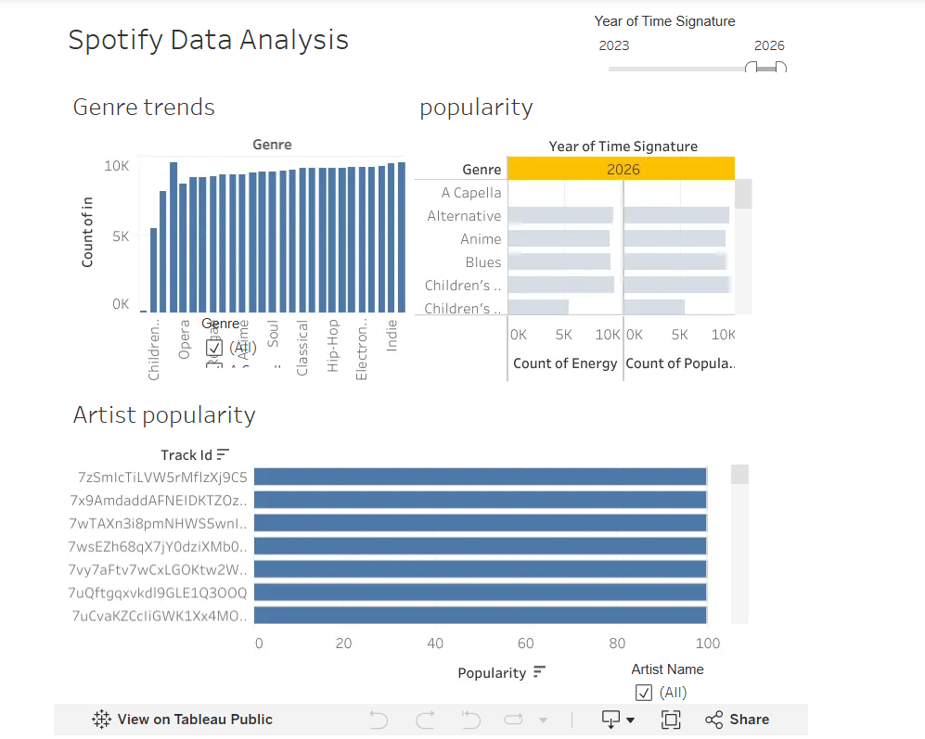  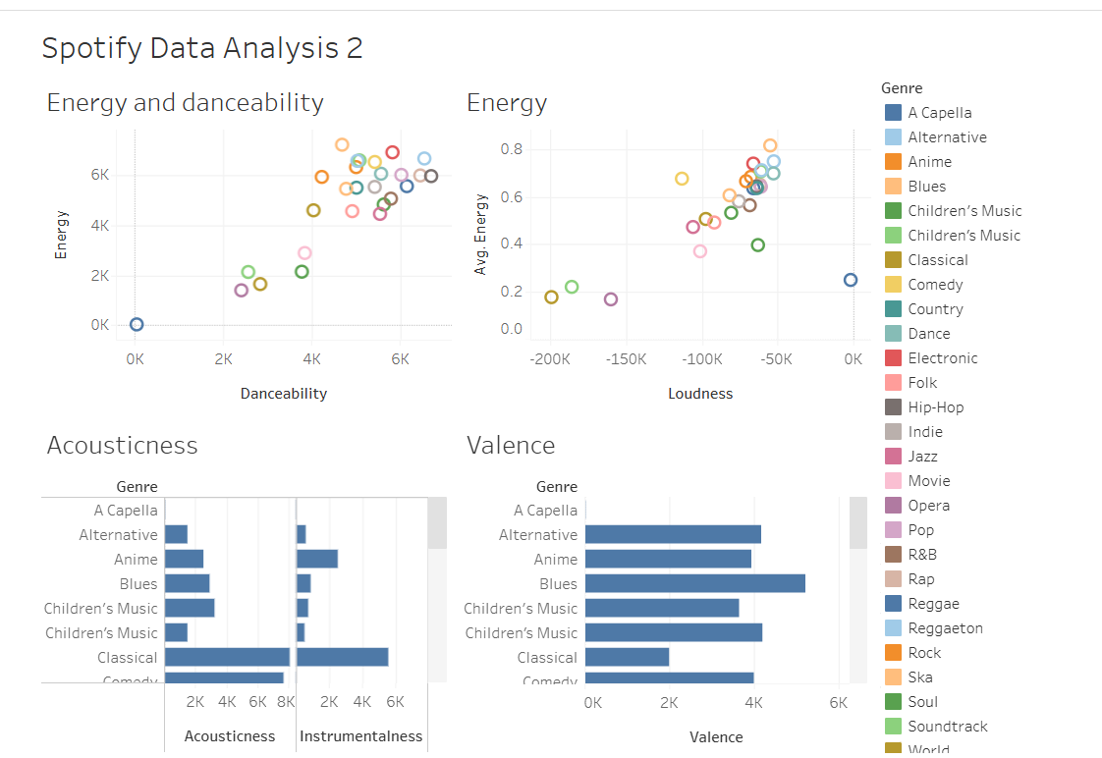

What did you find? | Looking at both Spotify dashboards, several clear patterns and trends emerge. The first chart shows that Hip-Hop, Indie, Soul, Opera and Children’s Music appear most frequently, and overall the genres seem evenly represented. It also demonstrates that some tracks achieve high popularity regardless of genre, which may be influenced by marketing, cultural relevance or wider social trends. This shows that popularity cannot be fully explained by audio features alone, and musical characteristics on their own do not determine how popular a track becomes.  Popularity analysis can help music organisers and promoters identify trends, emerging artists and currently popular music. This insight can support decision-making, event planning and targeted promotion within the industry.
Link to your dashboard | Spotify Data Analysis1 | Tableau Public  Spotify Data Analysis2 | Tableau Public

Day 3: Task 1
Please complete PL-300T00-A-Lab-02-LA] Clean, transform, and load data in Power BI
on XtremeLabs. Once complete, paste a print screen below and in the collaboration board.
- Visit https://labs.xtremelabs.io/
- Sing into your profile
- Go to View Labs
- Launch and complete PL-300T00-A-Lab-02-LA] Clean, transform, and load data in Power BI.

“Teaching is the best way to learn, so please listen out for support requests from the class and we’ll work through the challenges together”

Paste your completed lab here | 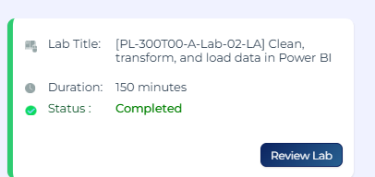  I am unable to publish my work on Power BI. My logins work fine on everything besides my PowerBI.  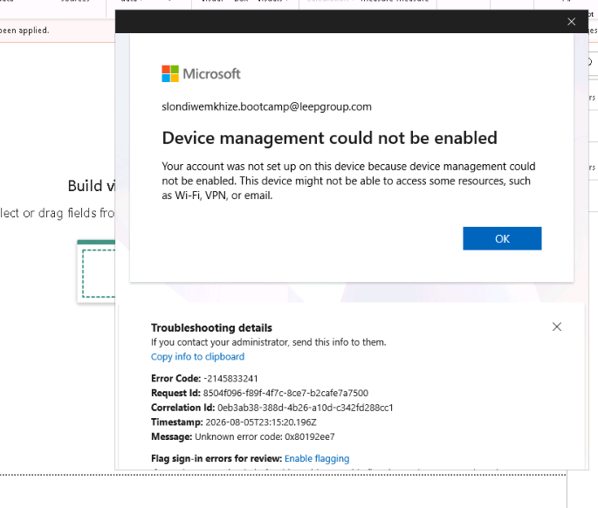  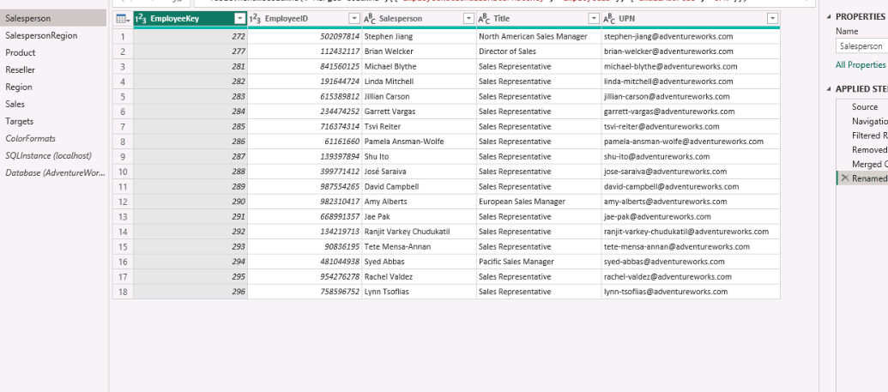  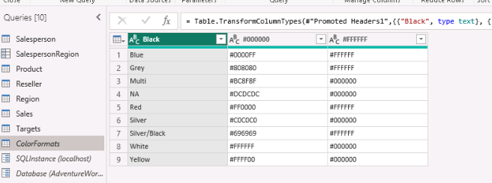  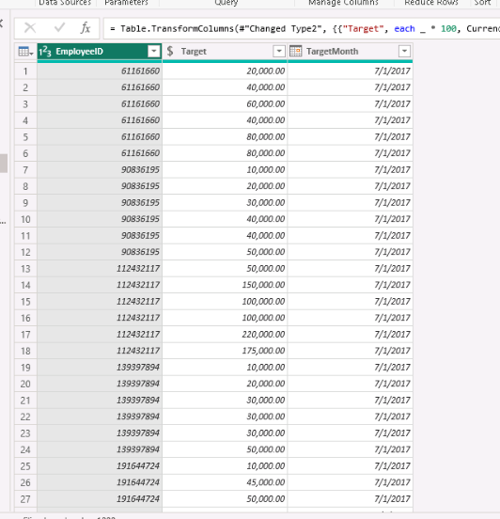  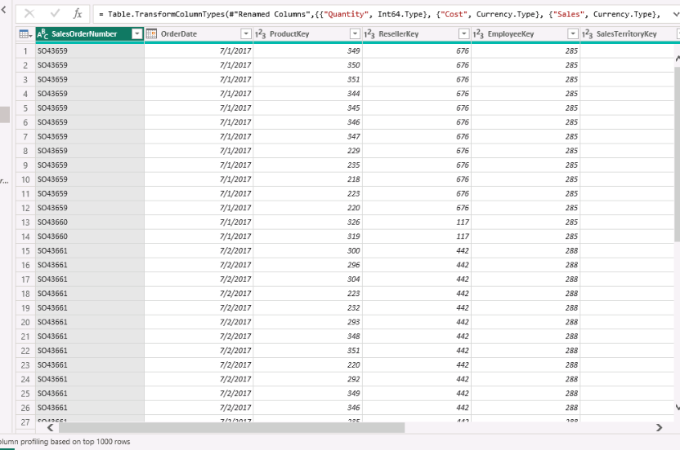  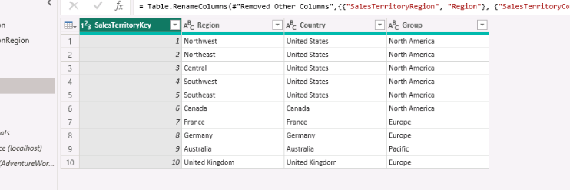  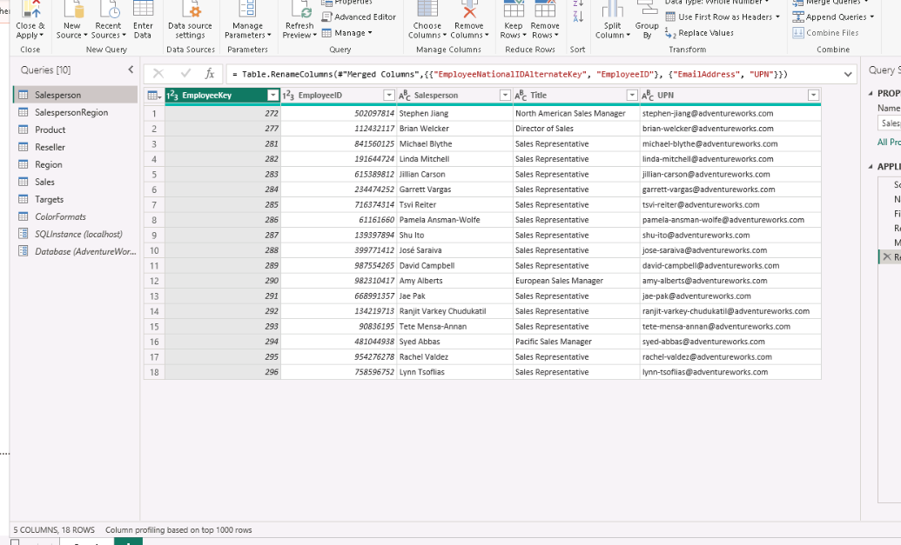  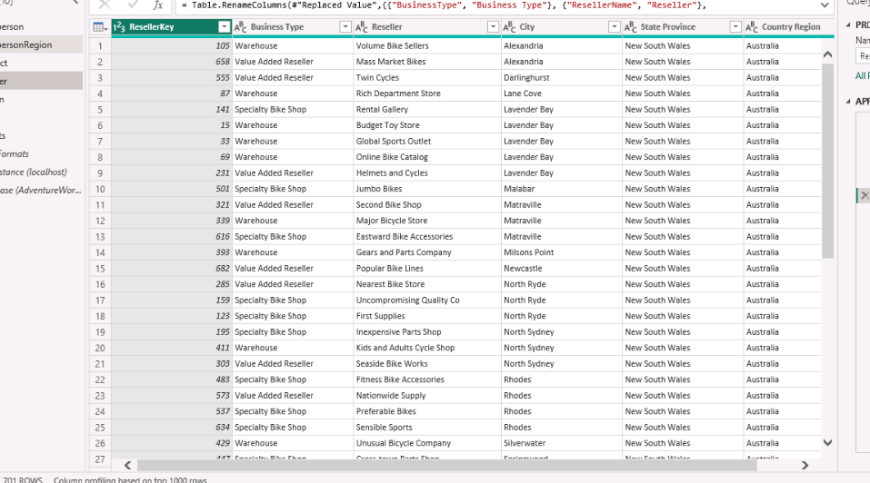  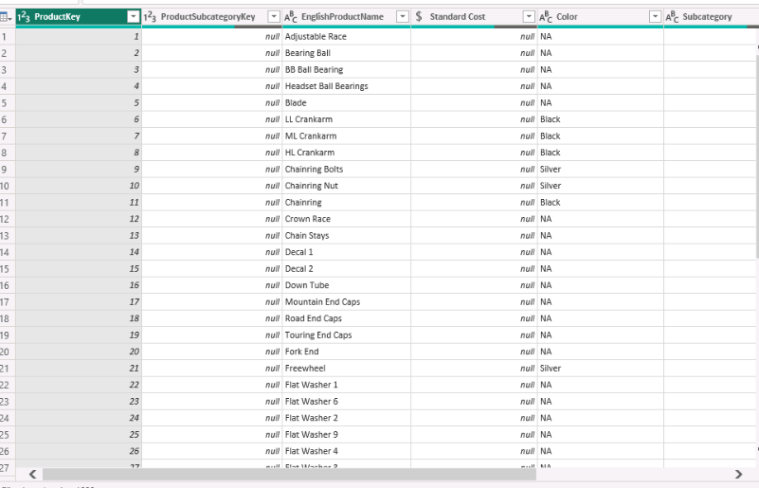

Day 3: Task 2 (Optional)

- Explore Power BI course on DataCamp. Introduction to Power BI

Once complete, publish your report in Power BI service and paste a print screen below and share with your trainer.

Paste your completed lab here

Day 4: Task 1

Please complete [PL-300T00-A-Lab-08-LA] Design Power BI reports on XtremeLabs. Once complete, paste a print screen below and in the collaboration board.
- Visit https://labs.xtremelabs.io/
- Sing into your profile
- Go to View Labs
- Launch and complete [PL-300T00-A-Lab-08-LA] Design Power BI reports.
“Teaching is the best way to learn, so please listen out for support requests from the class and we’ll work through the challenges together”

Paste your completed lab here | 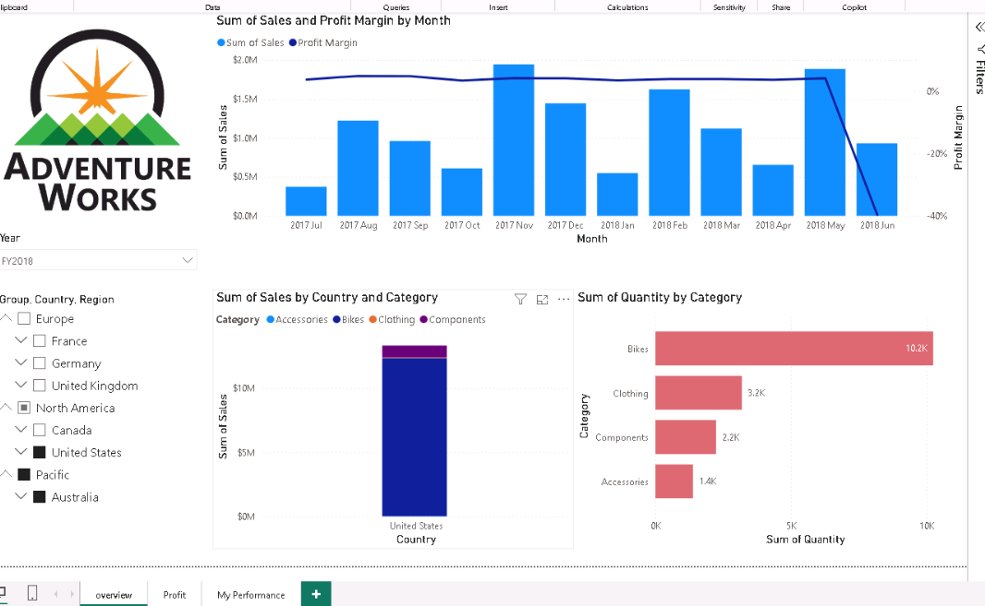  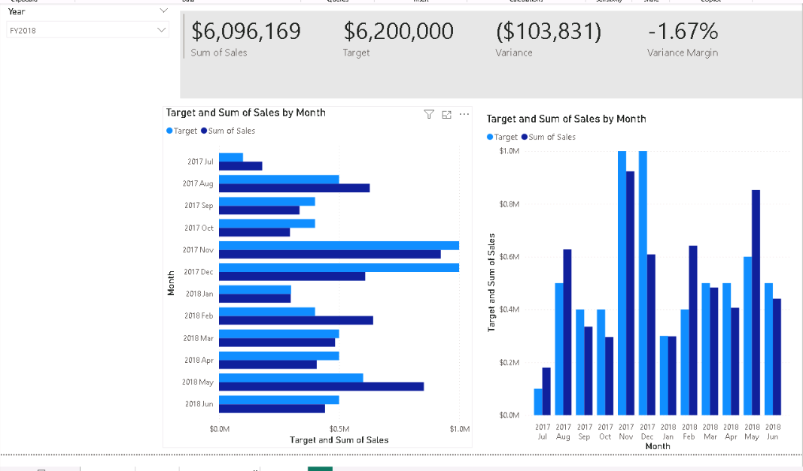  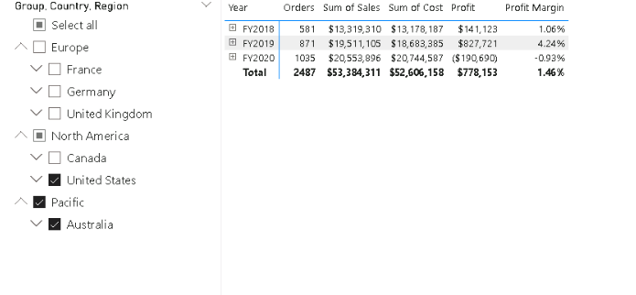  https://b2wcompletetraining057-my.sharepoint.com/:u:/g/personal/slondiwemkhize_bootcamp_leepgroup_com/IQA_gBE7XZL7S5uO5lxq9EEuAXI0Fd2bmIqsaLAUUEcwHx0?e=bPOUeR

Day 4: Task 2

Please complete [PL-300T00-A-Lab-04-LA] Create DAX calculations in semantic models on XtremeLabs. Once complete, paste a print screen below and in the collaboration board.
- Visit https://labs.xtremelabs.io/
- Sing into your profile
- Go to View Labs
- Launch and complete PL-300T00-A-Lab-04-LA] Create DAX calculations in semantic models.

“Teaching is the best way to learn, so please listen out for support requests from the class and we’ll work through the challenges together”

Paste your completed lab here | 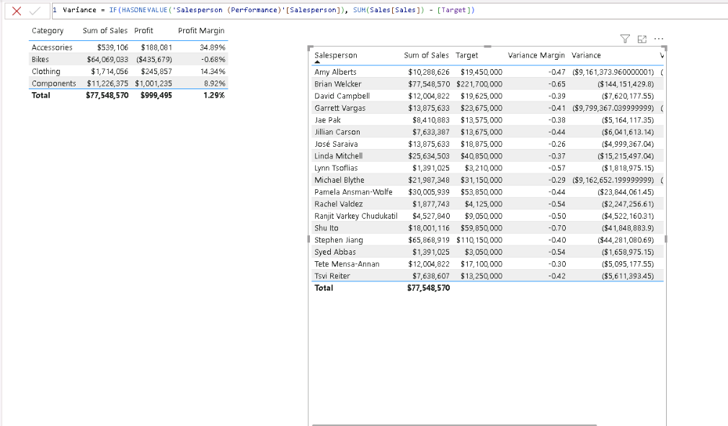  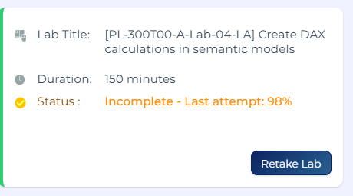

Day 4: Task 3 (Optional)

Please complete [PL-300T00-A-Lab-03-LA] Configure a semantic model in Power BI. on XtremeLabs. Once complete, paste a print screen below and in the collaboration board.
- Visit https://labs.xtremelabs.io/
- Sing into your profile
- Go to View Labs
- Launch and complete [PL-300T00-A-Lab-03-LA] Configure a semantic model in Power BI.

“Teaching is the best way to learn, so please listen out for support requests from the class and we’ll work through the challenges together”

“Teaching is the best way to learn, so please listen out for support requests from the class and we’ll work through the challenges together”

Paste your completed lab here | 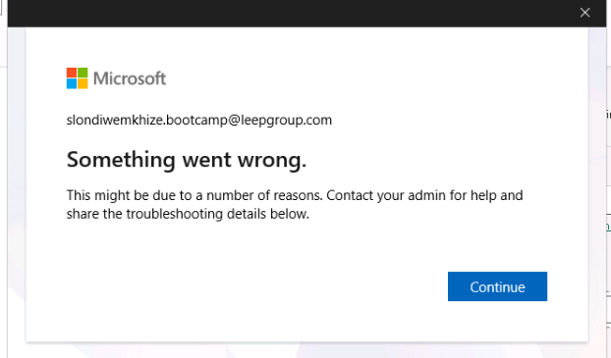  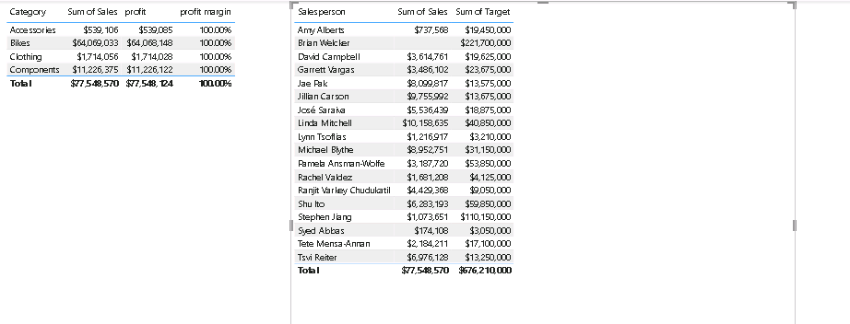  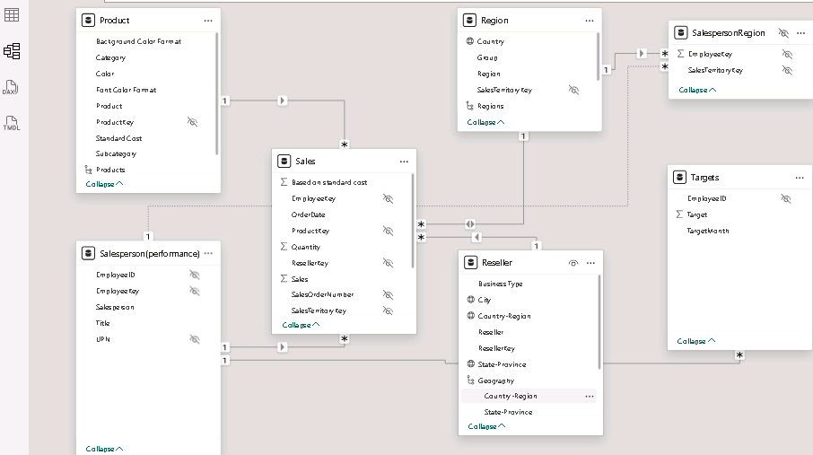  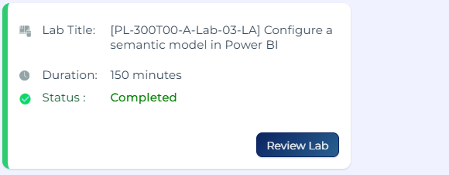

Course Notes

It is recommended to take notes from the course, use the space below to do so, or use the revision guide shared with the class:

Additional Resources to learn and Practice

- Full Beginner Project in Tableau | Tableau Tutorials for Beginners
- Learn Tableau Basic Calculations (Calculated Fields) in Tableau (with 10+ examples) | Part 1
- Tableau Hands-on Challenges Trailmix | Salesforce Trailhead
- Introduction to Tableau - DataCamp Learn
- Creating Dashboards in Tableau - DataCamp Learn
- Sample Data | Tableau Public
- How-To Videos | Tableau Public
- Power BI Cheat Sheet | DataCamp
- Introduction to DAX in Power BI - DataCamp Learn
- Data Visualization in Power BI - DataCamp Learn
- PL 300 Course on MS Learn. Course PL-300T00-A: Design and manage analytics solutions using Power BI - Training | Microsoft Learn This is an intermediate course.

END OF WORKBOOK

Please check through your work thoroughly before submitting and update the table of contents if required.

Please send your completed work booklet to your trainer.

